Project SCCS Risk Window Scanning
  - Descriptive Analysis
Trang Tu - Albert Chuang
Attaching package: 'dplyr'
The following objects are masked from 'package:stats':
filter, lag
The following objects are masked from 'package:base':
intersect, setdiff, setequal, union
here() starts at /Users/tranghien/Library/CloudStorage/OneDrive-UniversiteitUtrecht/My_PhD/Research/4_SCCS_Focal_Window/Analysis/SCCS_risk_window
Attaching package: 'lubridate'
The following objects are masked from 'package:base':
date, intersect, setdiff, union
Check the structure of imported files:
List of 7
$ individual :'data.frame': 166 obs. of 15 variables:
$ myo_sccs :'data.frame': 16 obs. of 21 variables:
$ pe_sccs :'data.frame': 62 obs. of 21 variables:
$ thrc_sccs :'data.frame': 9 obs. of 21 variables:
$ covid_infection:'data.frame': 49 obs. of 2 variables:
$ comorb_stat :'data.frame': 166 obs. of 6 variables:
$ covid_vacc_wide:'data.frame': 98 obs. of 5 variables:

Distributions of exposures and outcomes

Distribution of outcome events over the observation period:
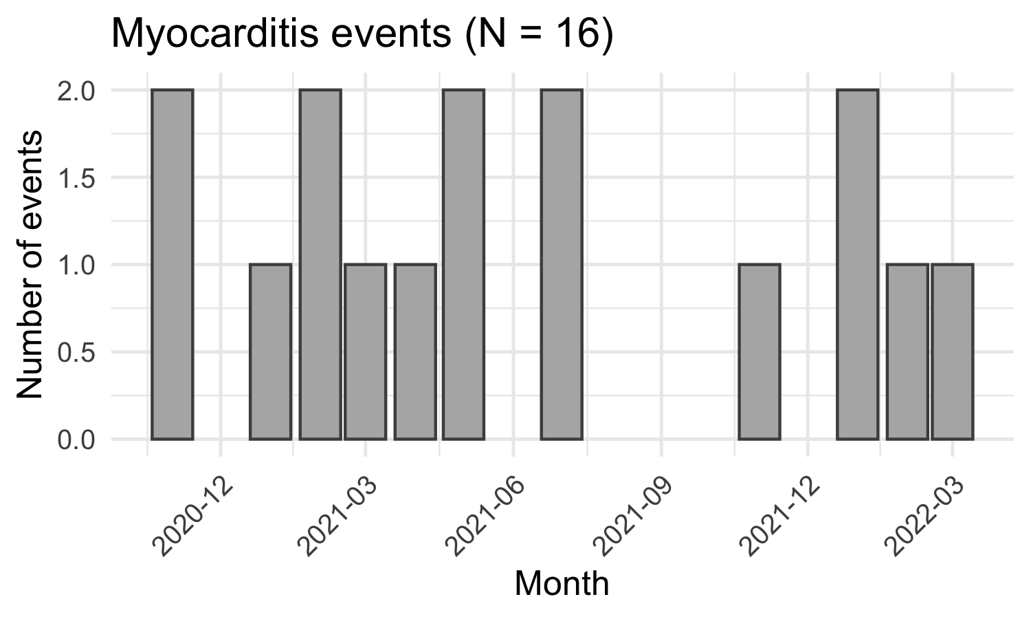
Figure 1: Monthly event counts by outcome
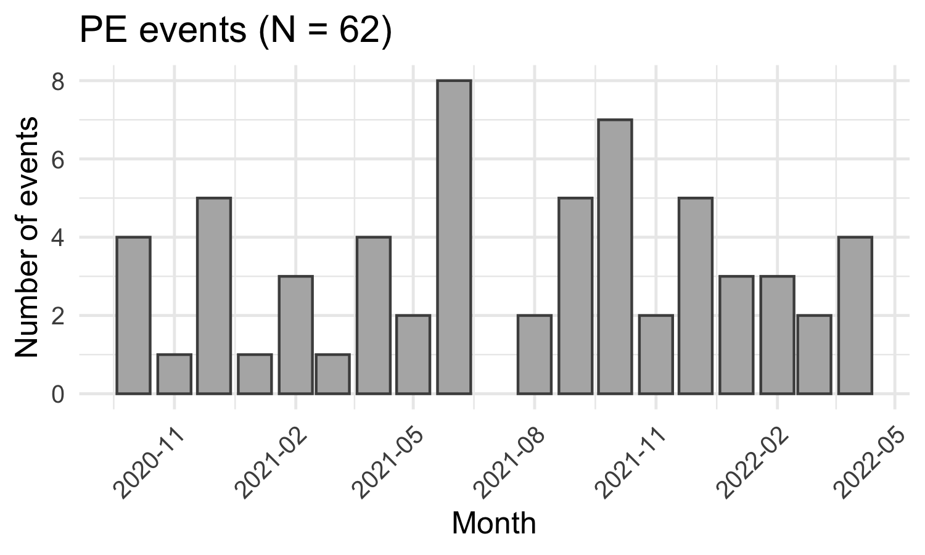
Figure 2: Monthly event counts by outcome
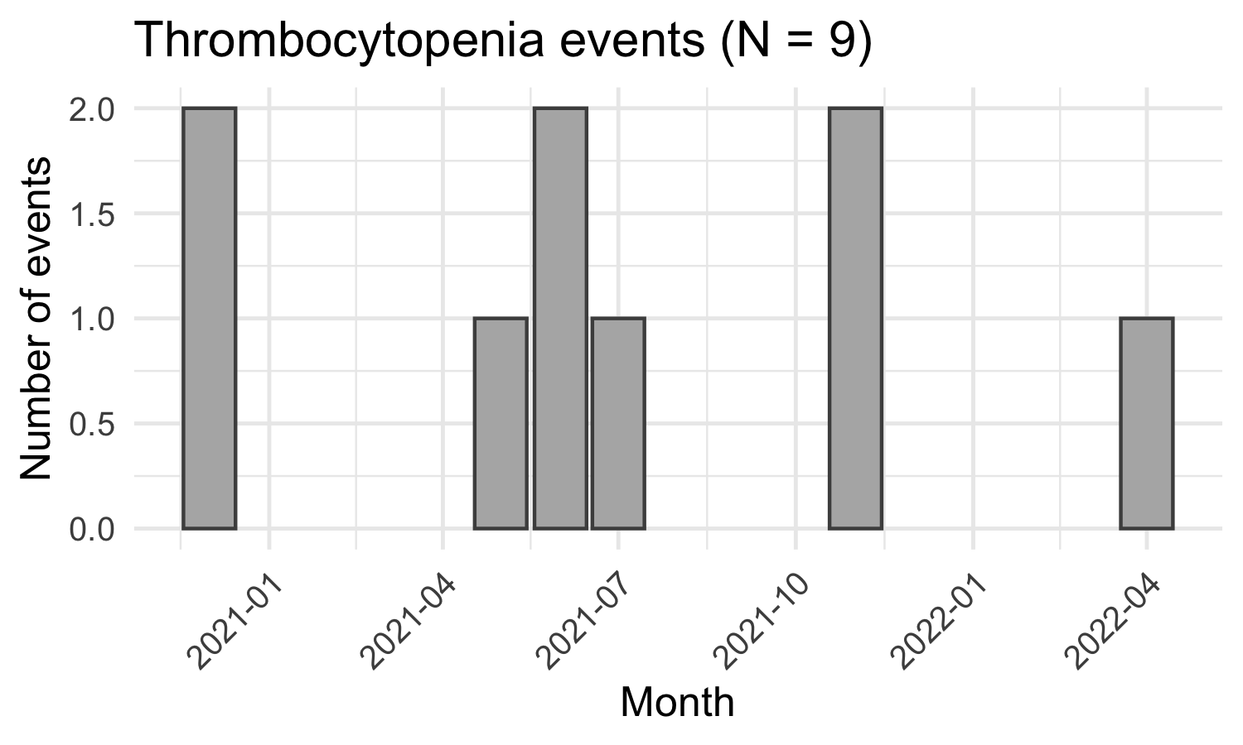
Figure 3: Monthly event counts by outcome

Distribution of vacc date
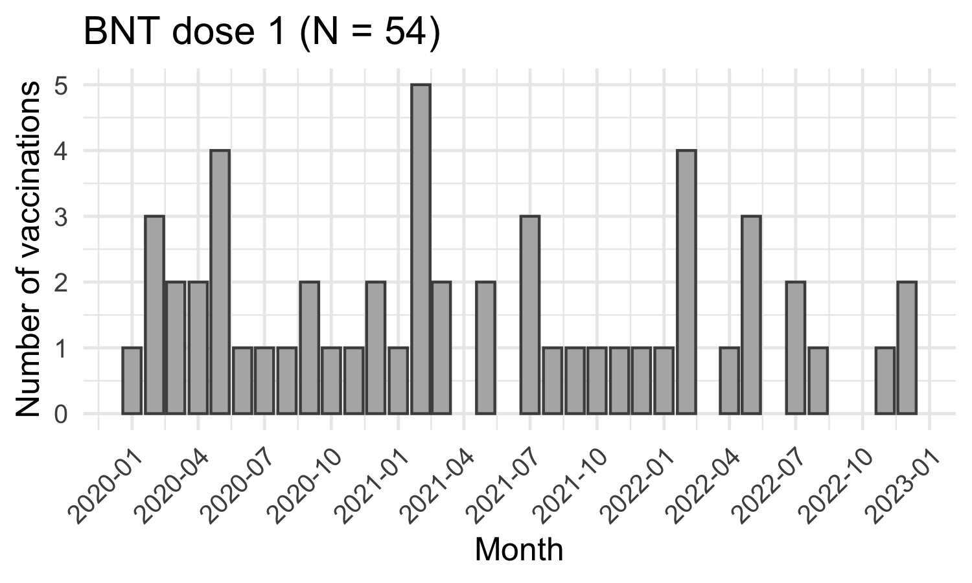
Figure 4: Monthly vaccination counts by vaccine brand and dose
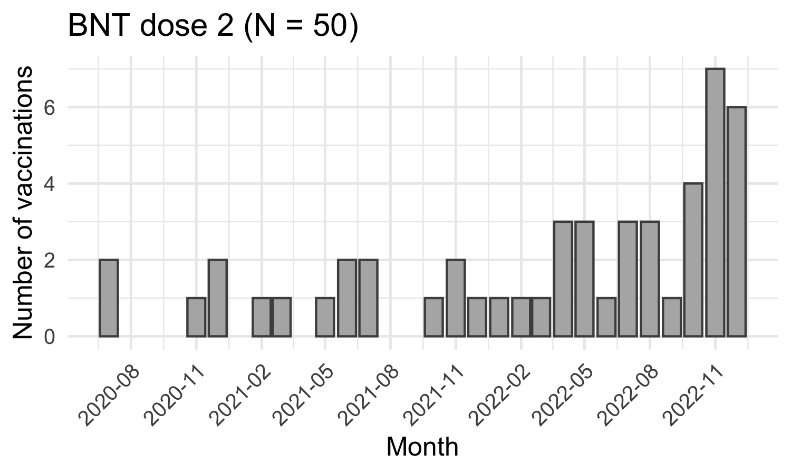
Figure 5: Monthly vaccination counts by vaccine brand and dose
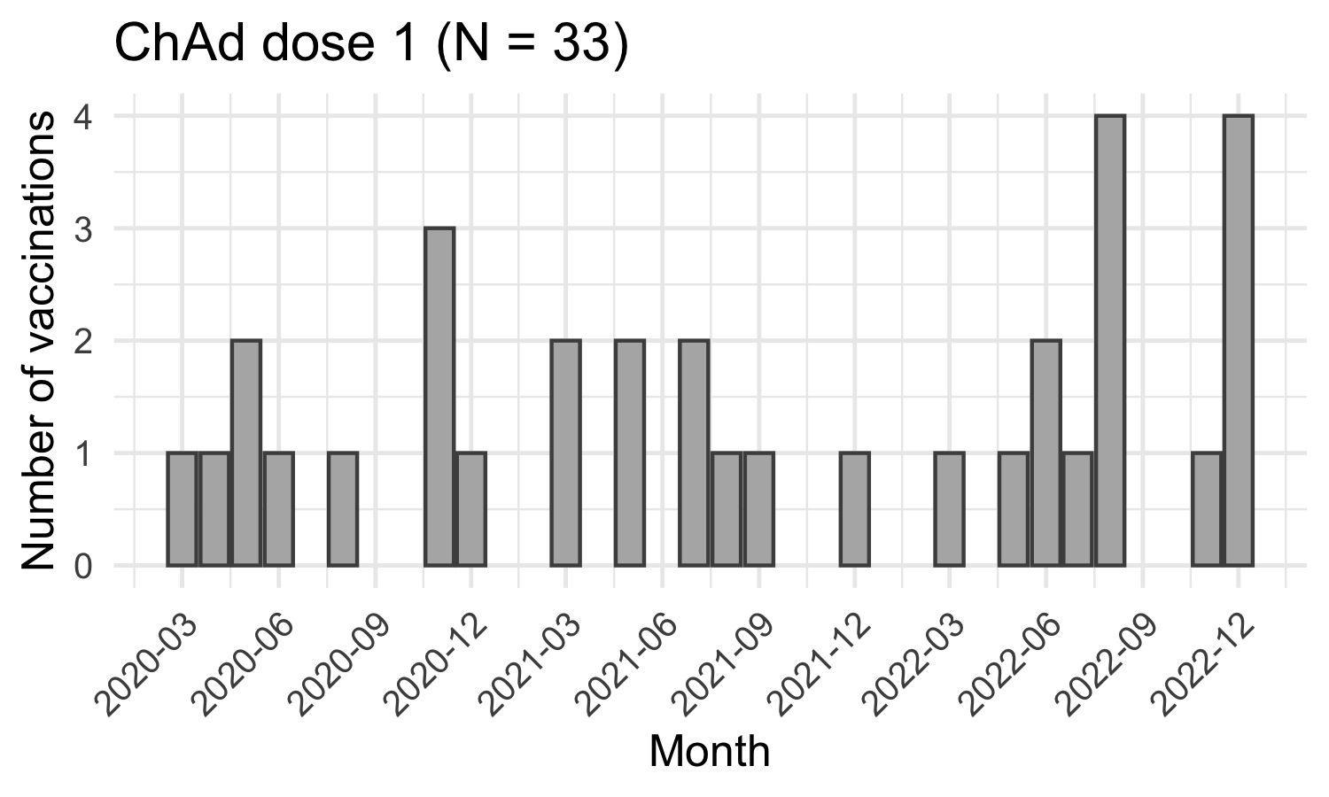
Figure 6: Monthly vaccination counts by vaccine brand and dose
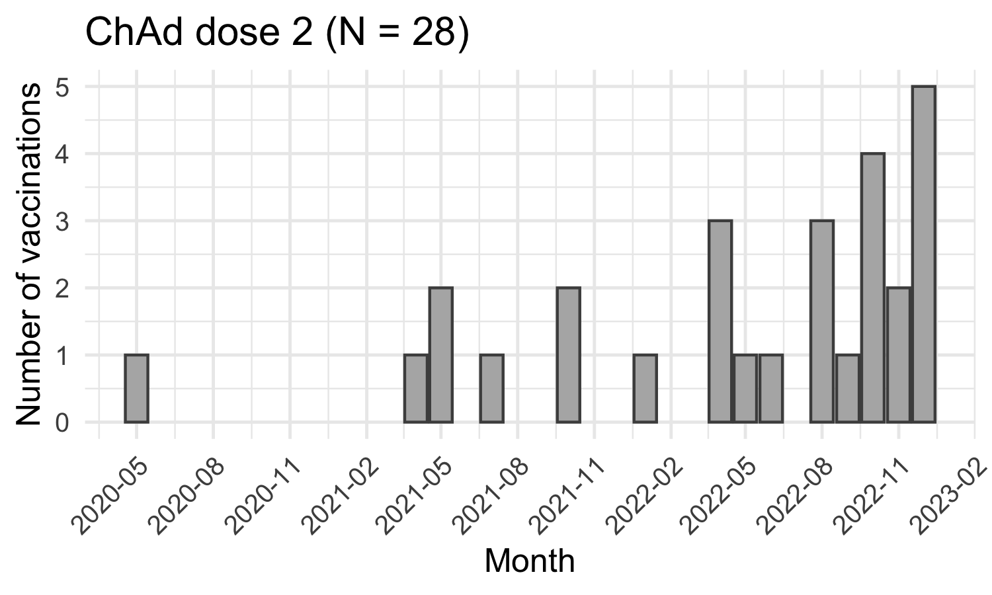
Figure 7: Monthly vaccination counts by vaccine brand and dose

Dosing interval
- bnt_interval and chad_interval: interval between vaccine dose 1 and the earliest of (dose 2, end of observation).
- bnt2_to_end and chad2_to_end: interval between dose 2 and end of observation.
bnt_interval bnt2_to_end chad_interval chad2_to_end
Min. :-2677.0 Min. :-2705.0 Min. :-1907.0 Min. :-2355.0
1st Qu.: -751.0 1st Qu.: -482.0 1st Qu.: -460.8 1st Qu.:-1452.5
Median : 68.5 Median : -213.5 Median : -78.5 Median : -230.5
Mean : -279.9 Mean : -464.9 Mean : -257.8 Mean : -603.1
3rd Qu.: 324.8 3rd Qu.: -37.0 3rd Qu.: 415.8 3rd Qu.: -29.0
Max. : 824.0 Max. : 646.0 Max. : 737.0 Max. : 399.0
NA's :44 NA's :48 NA's :74 NA's :70
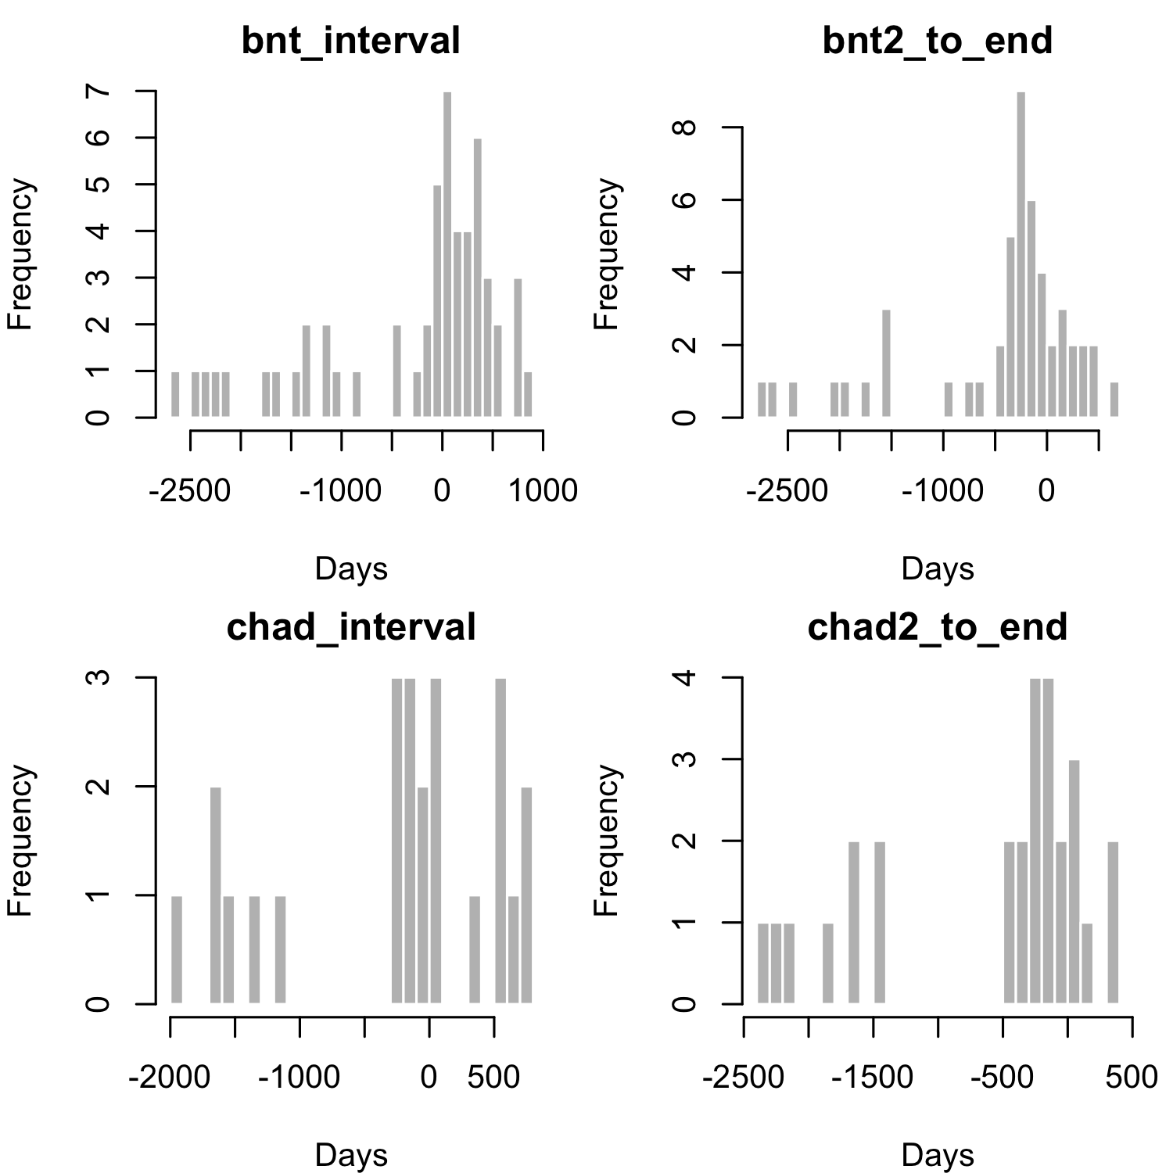
Figure 8: Interval in days between dose 1 and dose 2, and between dose 2 and end of observation

Distribution of 1st COVID-19 infection
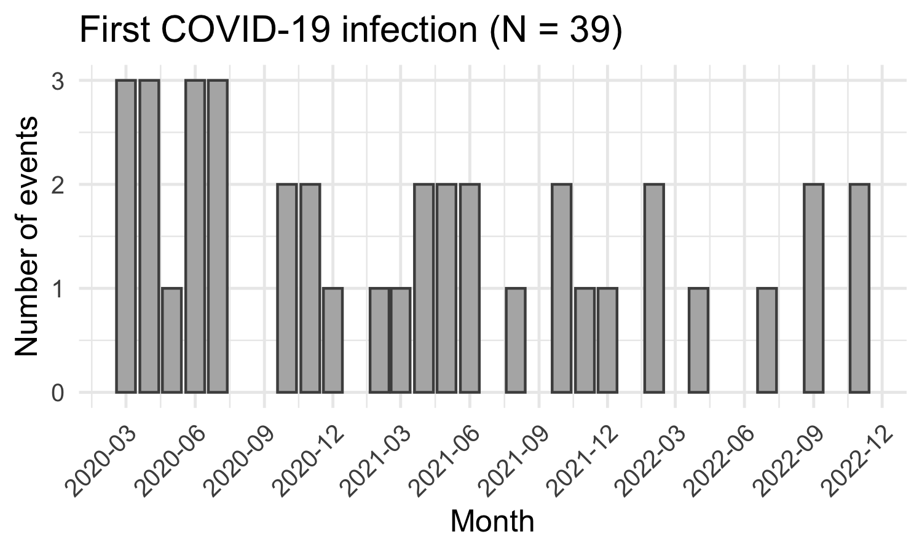
Figure 9: Monthly incidence of COVID-19 infection

Number of vaccinated cases (events could occur before or after vaccination)
Myocarditis (N cases = 16 )
case_bnt1 case_bnt2 case_chad1 case_chad2
1 8 9 3 2
PE (N cases = 62 )
case_bnt1 case_bnt2 case_chad1 case_chad2
1 24 21 16 14
Thrombocytopenia (N cases = 9 )
case_bnt1 case_bnt2 case_chad1 case_chad2
1 2 2 2 2

Check assumptions of SCCS model

Event-dependent observation period
- histogram of time from event until end of observation
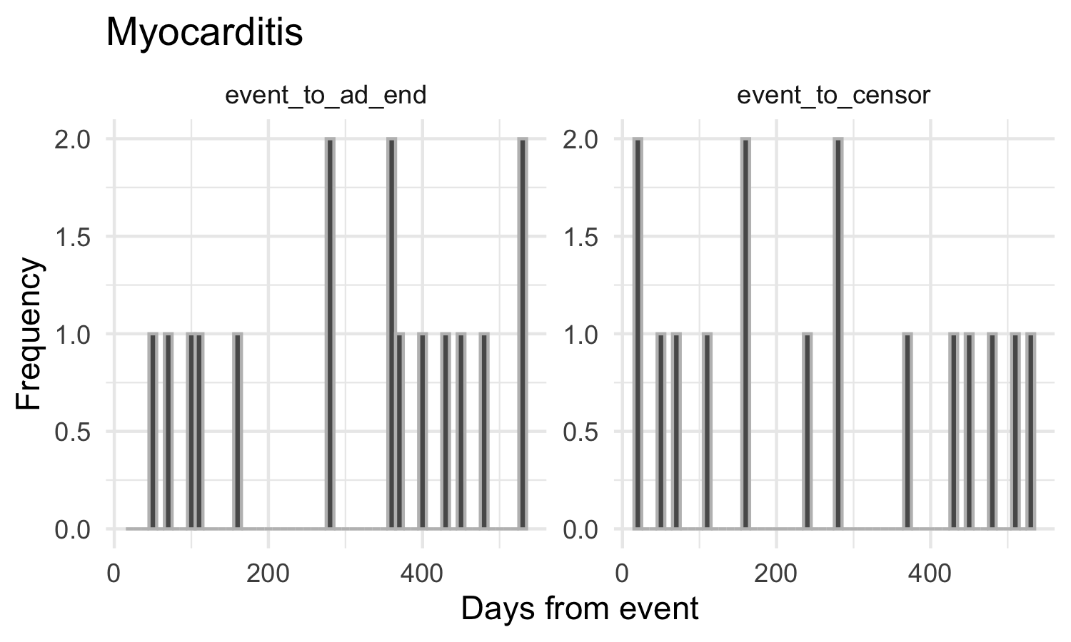
Figure 10: Distribution of time from event to end of follow-up
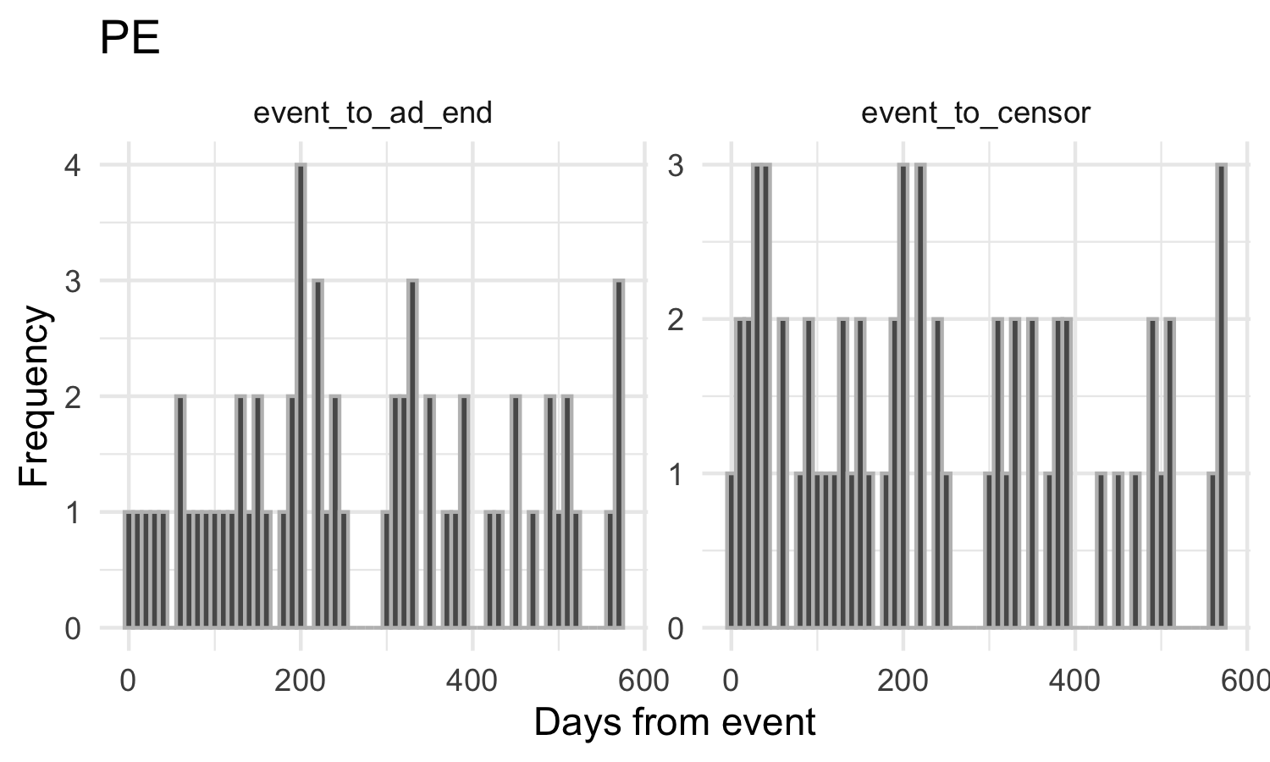
Figure 11: Distribution of time from event to end of follow-up
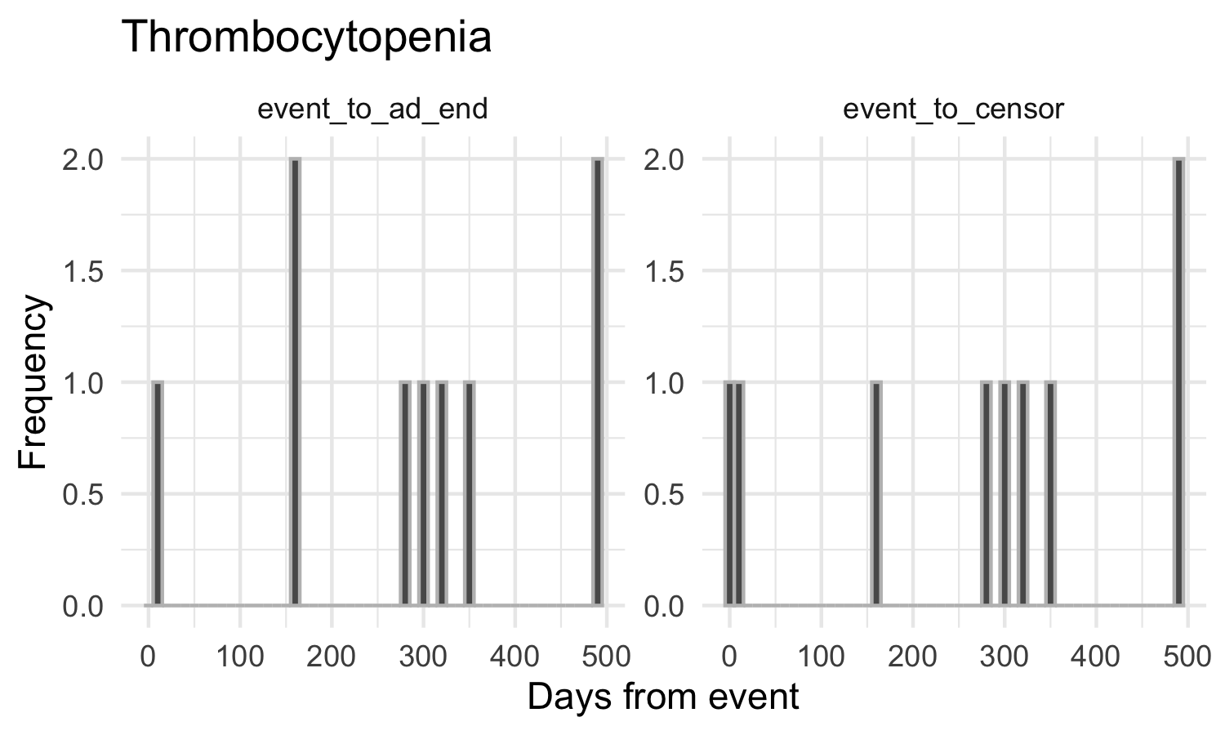
Figure 12: Distribution of time from event to end of follow-up

Event-dependent exposure
- Time interval between the start of each exposure and the event
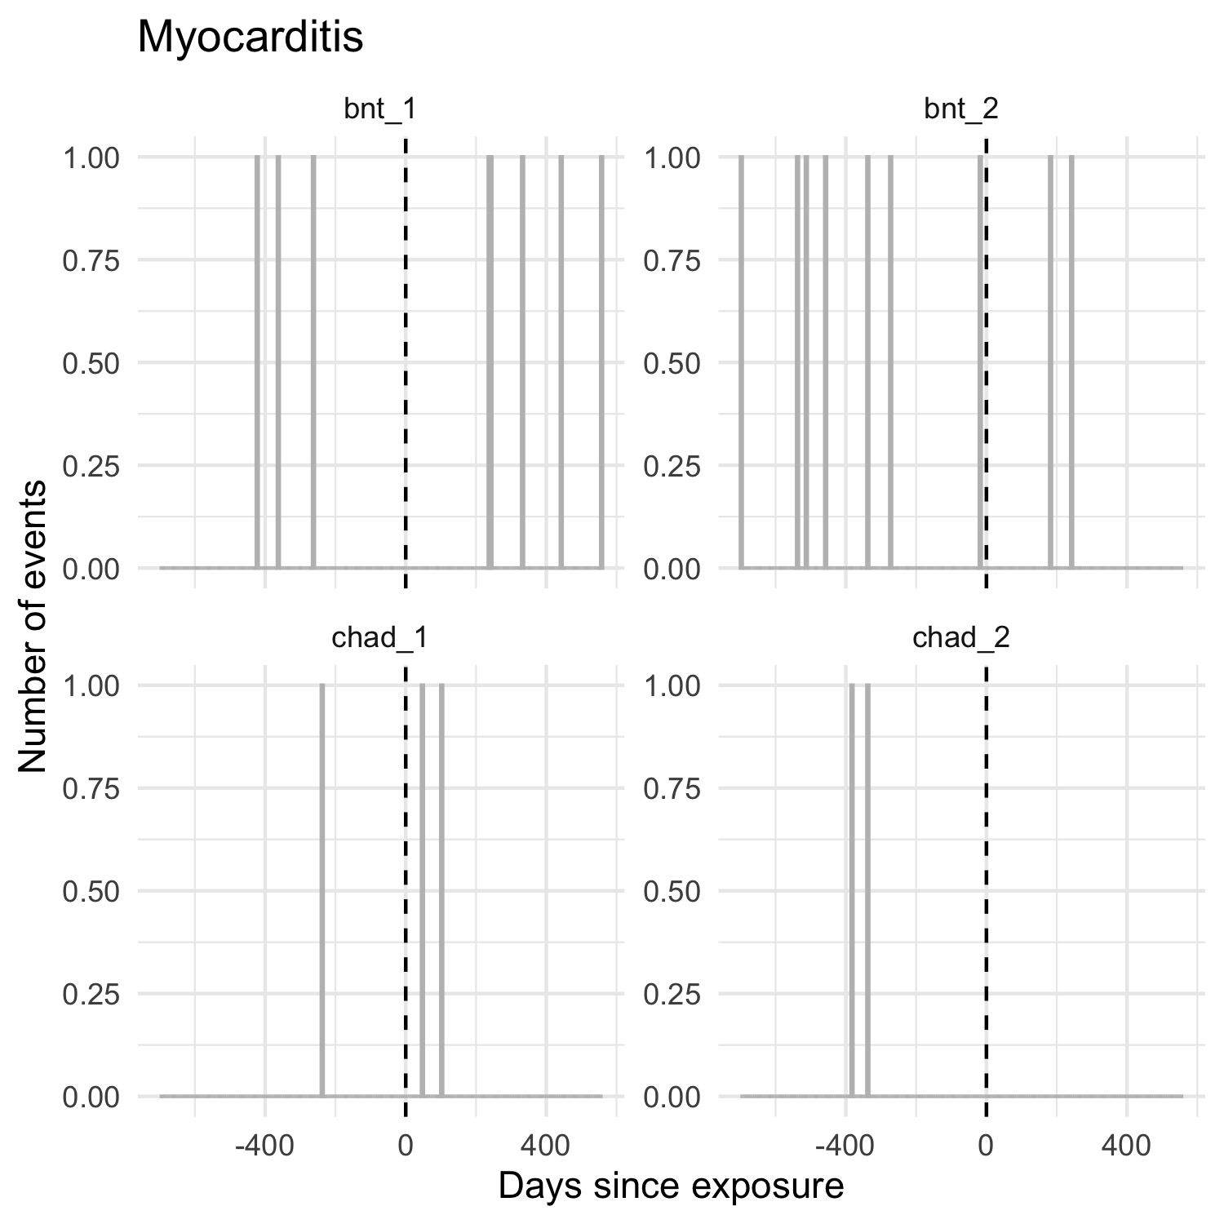
Figure 13: Number of events in exposed cases by time since exposure, for investigating event-dependent exposure
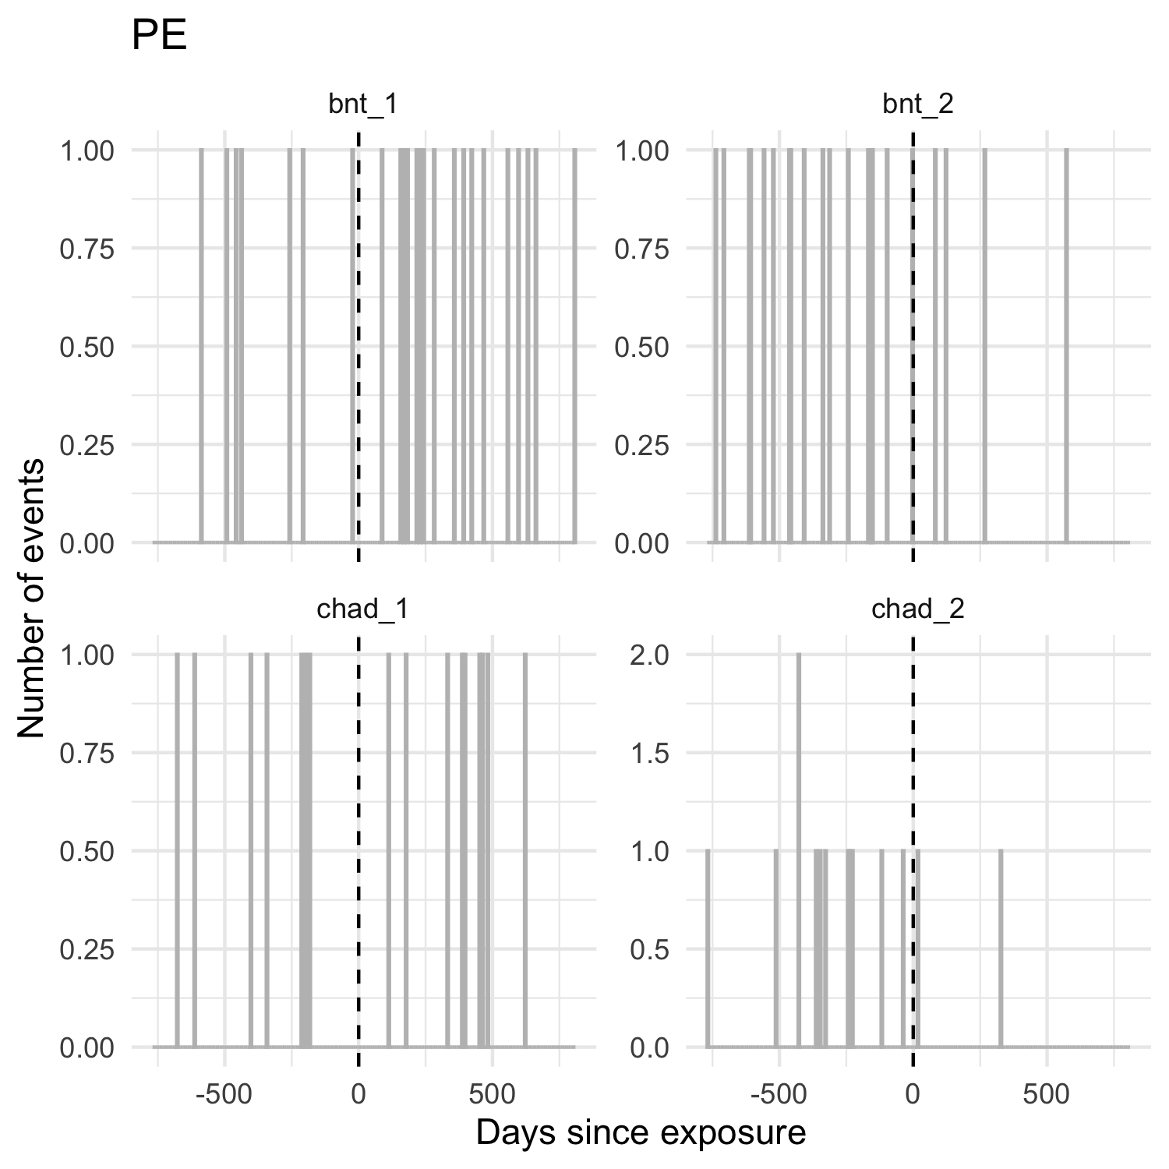
Figure 14: Number of events in exposed cases by time since exposure, for investigating event-dependent exposure
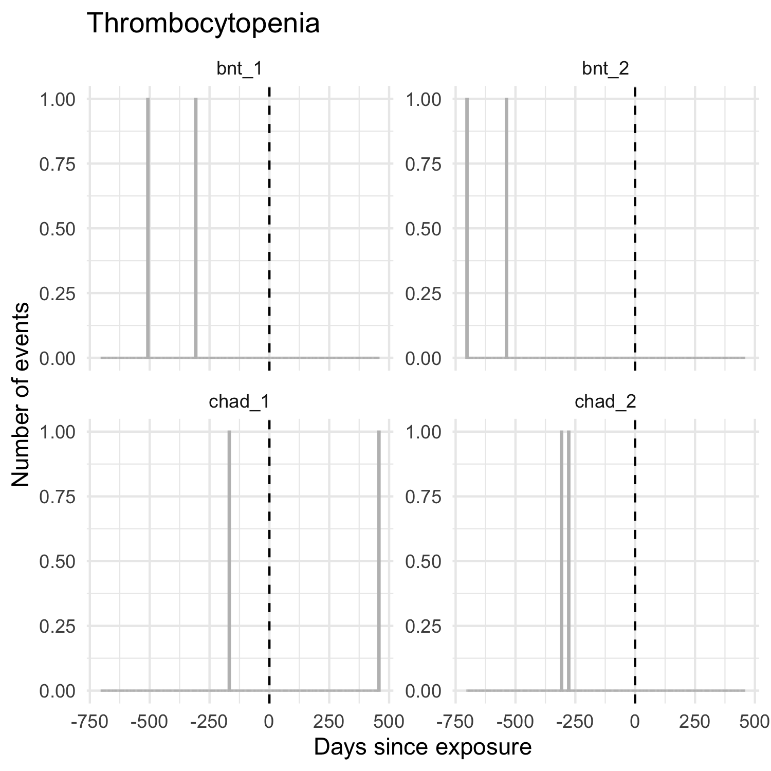
Figure 15: Number of events in exposed cases by time since exposure, for investigating event-dependent exposure
- Centred observation plots to help interpret the centred event plot
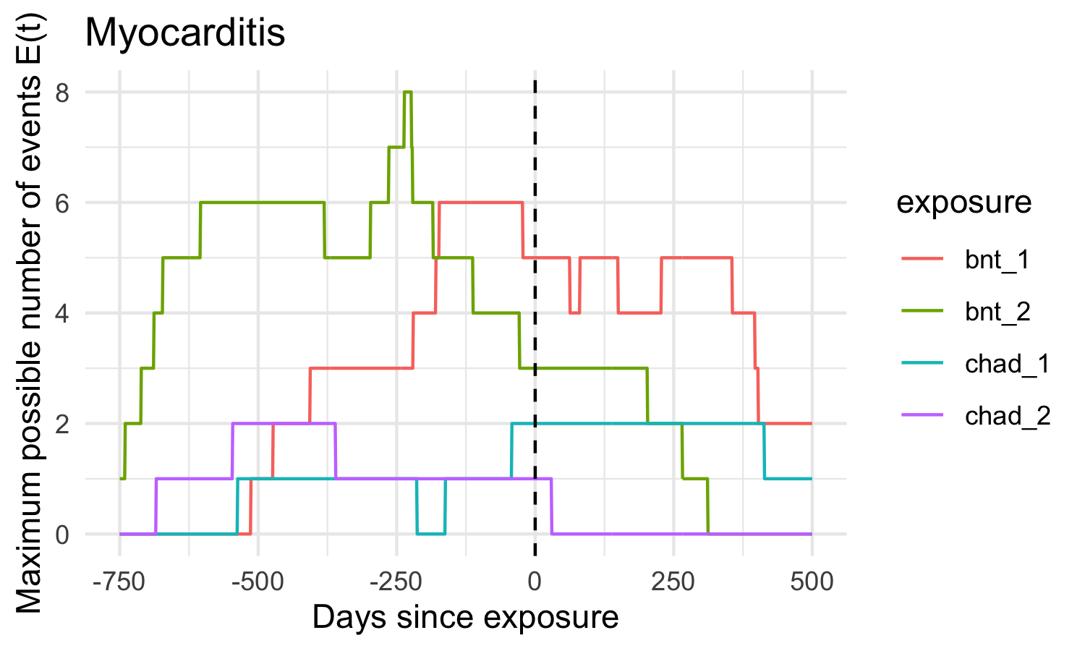
Figure 16: Centred observation plots: number of exposed cases under observation by time since exposure
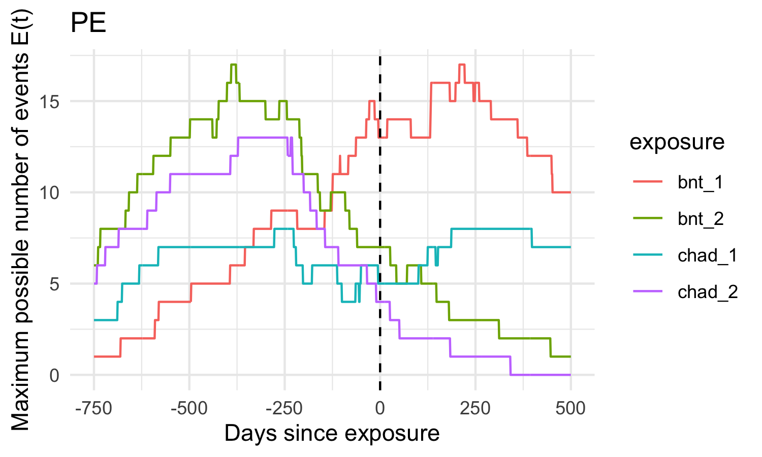
Figure 17: Centred observation plots: number of exposed cases under observation by time since exposure
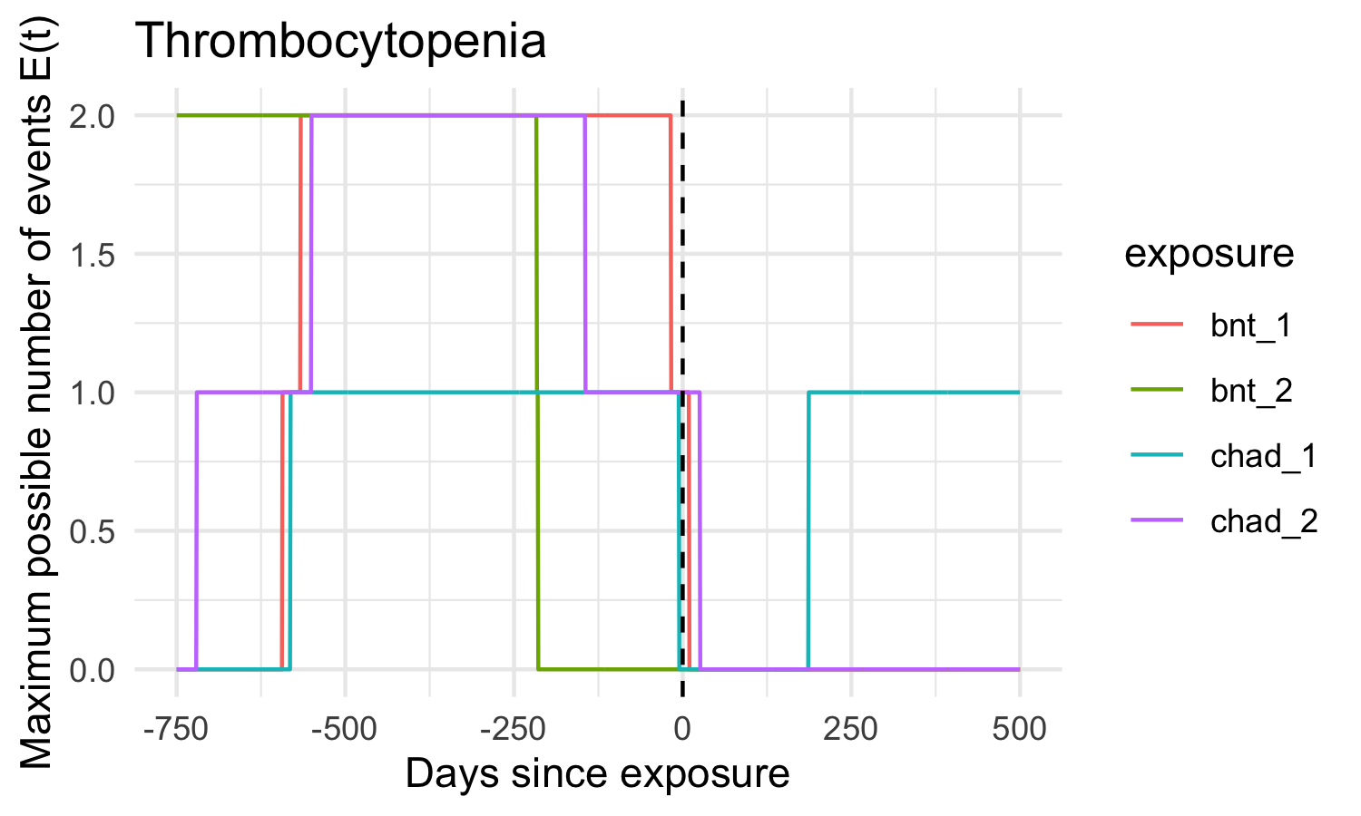
Figure 18: Centred observation plots: number of exposed cases under observation by time since exposure
The centred observation plot reflects design constraints: number of exposed cases that are under observation at a given time point (the hypothetical distribution of event relative to exposure if there is no event-dependent exposure).

Baseline characteristics of cases (per outcome)
Warning: Use of .data in tidyselect expressions was deprecated in tidyselect 1.2.0.
ℹ Please use `all_of(var)` (or `any_of(var)`) instead of `.data[[var]]`
Characteristic | Myocarditis (N = 16) | Pulmonary embolism (N = 62) | Thrombocytopenia (N = 9)
Age, median (IQR) | 52 (45–60) | 79 (65–89) | 85 (80–90)
Age, missing n (%) | 0 (0.0%) | 0 (0.0%) | 0 (0.0%)
Male, n (%) | 11 (68.8%) | 22 (35.5%) | 3 (33.3%)
Sex, missing n (%) | 0 (0.0%) | 0 (0.0%) | 0 (0.0%)
Lung disease, n (%) | 1 (6.2%) | 12 (19.4%) | 2 (22.2%)
Lung disease, missing n (%) | 0 (0.0%) | 0 (0.0%) | 0 (0.0%)
Chronic kidney disease, n (%) | 0 (0.0%) | 8 (12.9%) | 0 (0.0%)
Chronic kidney disease, missing n (%) | 0 (0.0%) | 0 (0.0%) | 0 (0.0%)
Diabetes, n (%) | 1 (6.2%) | 18 (29.0%) | 3 (33.3%)
Diabetes, missing n (%) | 0 (0.0%) | 0 (0.0%) | 0 (0.0%)
Cardiovascular disease, n (%) | 10 (62.5%) | 31 (50.0%) | 5 (55.6%)
Cardiovascular disease, missing n (%) | 0 (0.0%) | 0 (0.0%) | 0 (0.0%)
Cancer, n (%) | 1 (6.2%) | 4 (6.5%) | 0 (0.0%)
Cancer, missing n (%) | 0 (0.0%) | 0 (0.0%) | 0 (0.0%)

